W-11

**YEAR 12 PHYSICS**

**ASS. 1 - PROJECTILE MOTION**

**NAME: TOTAL: **

**DUE DATE:**

1. A pilot drops a package from an aircraft flying horizontally at a constant speed over flat ground.

Neglecting air resistance, when the package hits the ground, the horizontal location of the aircraft

will:

**A.** be behind the package.

**B.** be directly above the package.

**C.** be in front of the package.

**D.** depend on the speed of the aircraft when the package was released..

**E.** depend on the height of the aircraft when the package was released.

Answer (1)

Explain your answer.

(2)

2. The diagram below shows the trajectory of a golf ball (ignoring air resistance and any spin). The ball

moves from left to right as shown.

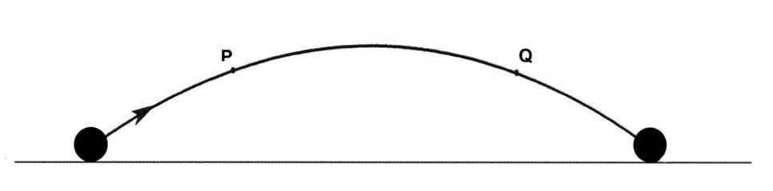

(a) With dotted arrows (like this ), show the direction of the resultant **velocity** of the ball

at positions P and Q.

(b) With solid arrows (like this ), show the direction of the resultant **acceleration** of the

ball at positions P and Q.

(2)

3. While serving a tennis ball, a tennis player aims to hit the ball horizontally

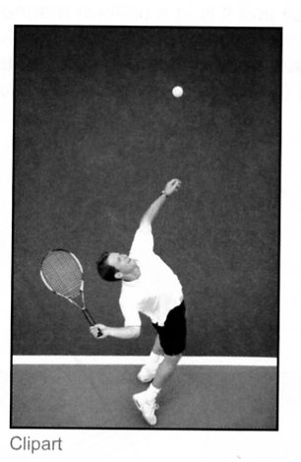 so that it lands in the opponent's court 5.50 m from the net. The height of

the net is 0.900 m, the distance between the service point and the net is

11.9 m and the ball is hit from as height of 2.80 m above the court.

(a) On the diagram below, draw the path of the ball with all the relevant

distances labelled.

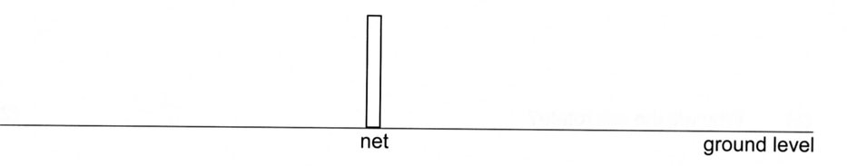

(2)

(b) Calculate the time taken for the tennis ball to reach the net and the minimum initial velocity that

the ball would need to just clear the net.

(4)

(c) Calculate the time it takes for the ball to hit the court.

(2)

(d) Calculate the distance from the net that the ball will land on the court on the opponent's side.

If you were unable to determine an answer in part (c), assume that the time of flight is 0.900 s.

If you were unable to determine an answer in part (a), assume that the initial speed is 20.0 ms-1.

(3)

4. A baseball leaves a bat at an angle of 30.0 ° to the horizontal when struck 1.20 m above the ground. It

moves with an initial velocity of 47.0 ms-1.

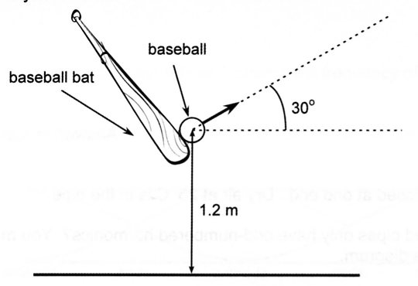

Assume that the air resistance is negligible. Working **must** be shown to gain full marks for this

question.

(a) Calculate the maximum height above the ground reached by the baseball.

(4)

(b) Calculate the vertical component of the velocity when the ball impacts the ground.

If you were unable to determine an answer to part (a), use 27.0 m as a value for the maximum

height.

(2)

(c) Calculate the time of flight of the baseball.

If you were unable to determine an answer to part (b), you should use 20.0 ms-1 as a value for

the vertical component of velocity when the ball hits the ground.

(3)

(d) Calculate the horizontal range of the baseball.

If you were unable to determine an answer to part (c), use 3.00 s as a value for the time of

flight.

(2)

5. A cork can leave a champagne bottle with a velocity greater than 15.0 ms-1. In 1988, a world record

was set when a cork travelled a horizontal distance of 54.1 m. In competition, champagne corks are

fired at 40.0 ° to the horizontal. In this question, ignore the effects of air resistance and assume the

cork is fired from ground level.

The range ***s*** of a projectile is given by the equation: ,

where ***vo*** is the initial velocity, ***t*** is the time of flight and *** *** is the angle to the horizontal.

The time of flight of a projectile is given by the equation: ,

where ***g*** is the acceleration due to gravity.

(a) Use the two equations above to show that the initial velocity for a projectile is:



(3)

(b) Calculate the initial velocity of the record-breaking champagne cork.

(2)

(c) Calculate the maximum height reached by the cork.

(3)

6. The diagram below shows part of a water fountain. It consists of three nozzles at ground level that

fire three short jets of water in parabolic paths (A, B and C) through the air. The jets of water fall into

three different holes in the ground. The centres of the holes are at the distances shown.

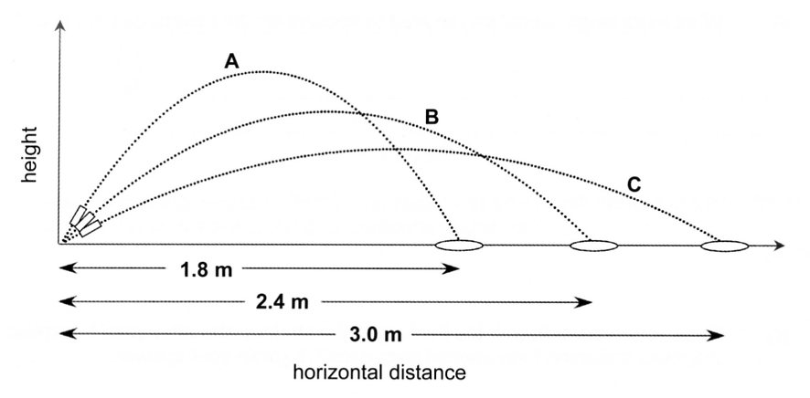

(a) The nozzle for B is directed at 45.0 ° above the horizontal. The water jet is in the air for 0.700 s

and lands in the middle of the hole. Calculate the initial velocity of the water jet.

(4)

(b) What is the maximum height reached by the water jet from nozzle B?

(3)

(c) The holes in the ground each have a diameter of 20.0 cm. The diameter of the water jet is

2.0 cm. If the wind is blowing horizontally with a constant velocity of 0.280 ms-1 in the

direction that the water travels, will the water jet following trajectory B still land in the hole?

Show sufficient working to justify your answer.

(3)

(d) The nozzle for A is directed at an angle of 60.0° above the horizontal and the nozzle for C is

directed at an angle of 30.0 ° above the horizontal. The initial velocity of A is 5.83 ms-1 and the

initial velocity of C is 4.52 ms-1.

If all three water jets leave at the same instant, in what order will they land in their respective

holes? Show sufficient working to justify your answer.

(3)